DRAFT ANNEX

SPECIFICATIONS FOR MSE TRIALS FOR BLUEFIN TUNA IN THE NORTH ATLANTIC
CONTENTS

1. BASIC CONCEPTS AND STOCK STRUCTURE 3
I) Spatial strata 3
Baseline 3
Alternative options 3
II) Temporal strata 4
III) Mixing hypotheses 4
Baseline 4
Alternative options 4
2. PAST DATA AVAILABLE 4
I) Raw data 5
II) Analysed data 5
III) Assumptions 7
3. BASIC DYNAMICS 9
I) Overview 9
II) Equations 10
Baseline 12
Alternative options 12
III) Fleet structure and exploitation history 13
Baseline 13
Alternative options 13
4. MANAGEMENT OPTIONS 13
I) Spatial strata for which TACs are set 14
Baseline 14
Alternative options 14
II) Options for the frequency of setting TACs 14
Baseline 14
Alternative options 14
III) Upper limits on TACs 15
IV) Minimum extent of TAC change 15
Baseline 15
Alternative options 15
V) Maximum extent of TAC change 15
Baseline 15
Alternative options 16
VI) Technical measures 16
5. FUTURE RECRUITMENT AND DISTRIBUTION SCENARIOS 16
I) West 16
II) East + Mediterranean 16
III) Future regime shifts 16
West 16
East+Med 17
IV) Statistical properties 17
Baseline 17
Alternative options 17
V) Possible future distributional changes 17
6. FUTURE CATCHES 17
Baseline 17
Alternative options 18
7. GENERATION OF FUTURE DATA 18
I) Baseline suggestions 18
West 18
East+Med 18
II) Alternative options 18
III) Relationships with abundance 19
IV) Statistical properties 19
Baseline 19
Alternative options 19
Other aspects 19
8. PARAMETERS AND CONDITIONING 21
I) Fixed parameters 21
II) Estimated parameters 21
III) Model predictions to compare with past data and likelihood functions 22
IV) Characterising uncertainty 25
Baseline 25
Alternative options 25
9. TRIAL SPECIFICATIONS 26
A. Reference set 26
B. Robustness trials 26
10. PERFORMANCE MEASURES/STATISTICS 27
I) Summary measures/statistics 27
II) Summary plots 28
III) Level of reporting 28
Baseline 28
Alternative options 28

BASIC CONCEPTS AND STOCK STRUCTURE

This first item intends to cover only the broadest overview issues. More detailed technical specifications are included under subsequent items.

Spatial strata
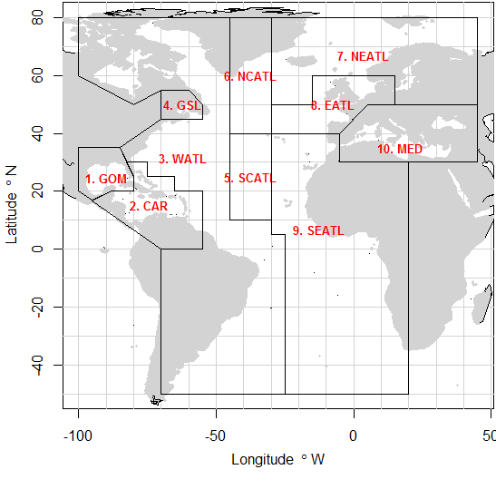

Figure 1.1. Spatial definitions tabled by the 2015 ICCAT data preparatory meeting (Anon. 2015) with simplification to a single Mediterranean area.

Baseline

Spatial areas at the resolution of the reported PSAT tagging data and the stock of origin data (which do not have sufficient resolution to divide the Mediterranean area into Eastern and Western sub areas)(Figure 1.1)

Alternative low priority future options

The MAST model (Taylor et al. 2011) areas which are the same Figure 1.1 but simplified such that the Central Atlantic is merged with the Western Atlantic.

B
A

Figure 1.2. Mixing hypotheses suggested by Arrizabalaga et al. 2014).
(A) A two stock model with no sub-populations.
(B) A two stock model with sub-population structure.
(C) A complex 2+ stock model.
C

Baseline

A two-stock model similar to Figure 1.2A but adhering to the spatial structure of Figure 1.1A.

Possible alternative options

A two-stock model with no mixing

PAST DATA AVAILABLE

Table 2.1 provides an overview of the data that may be used to condition operating models for Atlantic bluefin tuna. The Table indicates those data that have been gathered, those that are currently available and those that have already been used in conditioning operating models.

Raw data

A preliminary demonstration operating model has been fitted to the fishery, tagging and survey data that are currently available (Table 2.1, field ‘Used in OM’). Currently the operating model is fitted to ICCAT Task II landings data scaled upwards to annual Task I landings.

The ICCAT catch at size data set was used to estimate gear selectivity for each of the baseline fleet types.

The pop-off satellite archival tag data from several sources (NOAA, DFO, WWF, AZTI, UNIMAR, IEO, UCA, FEDERCOOPESCA, COMBIOMA, GBYP, Stanford University) have been compiled by NOAA (M. Lauretta) and used in the preliminary model to estimate movements among areas. In total 319 tags provided information on 929 quarterly transitions (Table 2.2).

Catch data provide scale to stock assessments. In a similar way, spatial stock of origin data are necessary to estimate the relative magnitude of the various stocks in a multi-stock model (to correctly assign catches to stock). Currently the model uses stock of origin data derived from the otolith microchemistry research of AZTI, UMCES and DFO (Table 2.3).

There is uncertainty in regard to the stock of origin of bluefin catches in the South Atlantic which reported prior to 1970. Currently these are dealt with in the same way as all other catches: they are assigned to the areas of Figure 1.1A by uprating Task II catches (that are reported spatially) to the annual Task I catch data. It follows that these South Atlantic catches are combined with north Atlantic catches in the areas W.Atl and E.Atl (Figure 1.1A) and assumed to have the same stock of origin. Currently all the stock of origin data come from analyses undertaken in the north Atlantic only (e.g. otolith microchemistry).

Analysed data

In the absence of a trip-level and fleet specific regional abundance index, preliminary standardized CPUE indices were derived from the following linear model (for more detail on this approach see Carruthers 2017, SCRS/2017/019):

$\log\left({CPUE}_{y,r,m,f}\right)=α_{y,r}+β_{m,r}+δ_{f,r}+ε$ (2.1)

where y, r, m and f refer to years, areas, subyears and fleets, respectively.

Table 2.2. The fleets used to derive the preliminary master index.

Flag | Gear | Total historical catches
Japan | Longline | 1.38m fish
USA | Longline | 13,156 fish
Canada | Rod and reel | 9,131 tonnes
Morocco | Trap | 15,996 tonnes
Spain | Baitboat | 35,625 tonnes

By including multiple fleets this index can be used to predict relative abundance indices over a wide range of year, subyears and areas (Figure 2.1).

A Western larval index (Lamkin et al., 2014) commencing in 1977 and an Eastern larval index of (Ingram et al., SCRS/2015/035) (2001-2005 and 2012-2013) exist for the Gulf of Mexico and Western Mediterranean, respectively.

In order to fit a preliminary operating model a naïve inverse age-at-length key (probability of length strata given age) was developed from the base-case stock assessment growth curves for Eastern and Western stocks and an assumed coefficient of variation of 10%.

There are four sources of derived data that are priorities moving forward:
- a defensible inverse age-length key for each stock preferably disaggregated by time,
- finalized fishery-independent larval surveys for both the Western and Eastern stocks,
- standardized abundance indices based on trip-level catch rate data and
- electronic tag data by age class
- (most importantly) a greater quantity of stock of origin data by age class spanning a greater range of subyear and area combinations.

Note that the preliminary operating model has been fitted to a relative abundance index derived from ICCAT task II catch and effort data, primarily those from the Japanese longline fleet. Set specific data are not available at this level, such as hooks per basket (depth), bait type and soak time that often substantially affect the derived index of abundance. It is important to produce a trip-level index that is standardized for these covariates if possible.

Further, currently the stock of origin data are relatively numerous but very sparse and only available for about 20% of subyear-area combinations (Table 2.3) (currently the operating model does not have stock of origin data for the Western Mediterranean and the Gulf of St Laurence). Coupled with sparse PSAT tagging data at this resolution (Table 2.2), there is limited information to estimate age-specific movement and allow the model to apportion catches to stock in these time-area strata correctly. There are however a large number of studies that may provide estimates of the stock of origin the data of which are not currently used to condition the operating model (e.g. otolith microchemistry, SNP, otolith shape and mitochondrial DNA analyses). Along with additional electronic tagging data by age class, provision of these stock of origin data by age class is arguably the highest priority for successfully conditioning future operating models.

Assumptions

The following are the default assumptions made in the model. Some of them may be relaxed in the robustness trials.

The age-length key is static and not adjusted according to fishing mortality rate and length selectivity of fishing.

CPUE indices are considered to be proportional to exploitable biomass (weighted by the selectivity indices).

Larval indices are assumed to be proportional to spawning stock biomass in the area in which they were collected in contrast to stock-wide spawning stock biomass (for scenarios where the two are not proportional).

Table 2.1. Overview of data that may be used to inform operating models for Atlantic bluefin tuna. Cells shaded green reflect sources for which data are available (‘Collab’,the Core modelling group CMG, or the ICCAT secretariat) and whether data that are available have also been used in conditioning preliminary operating models (‘used in OM?’). The table can be accessed: https://docs.google.com/spreadsheets/d/13pFaM3BTnzQ1B NQGoYn4O2n1IeD18V3VTbN9Hv7139U/edit#gid=1352276725. 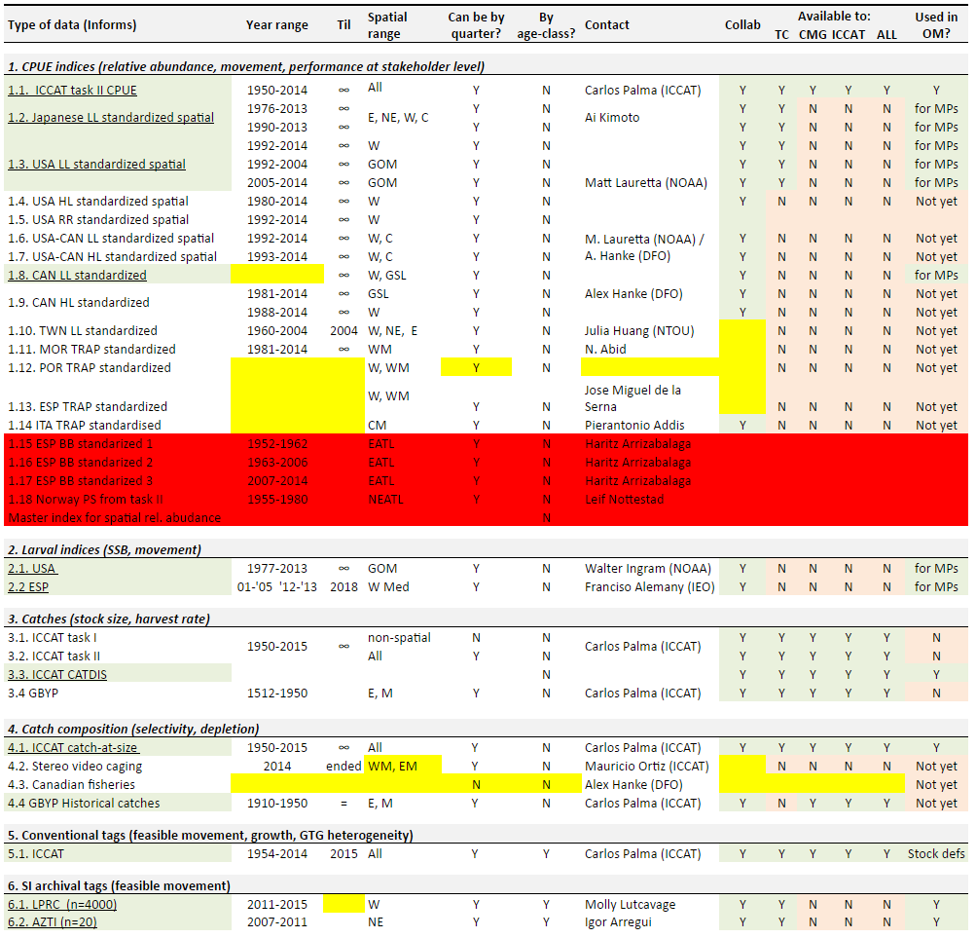
Table 2.1 continued.
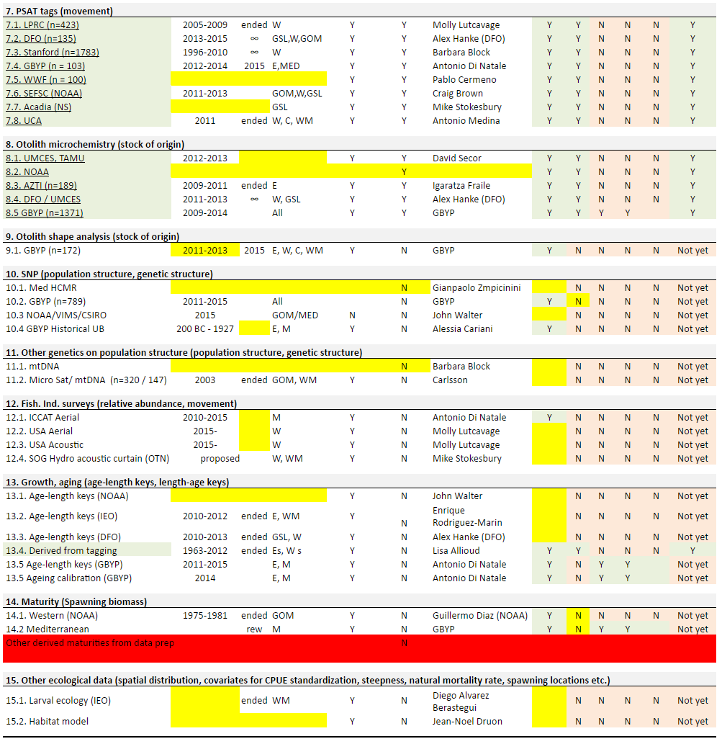

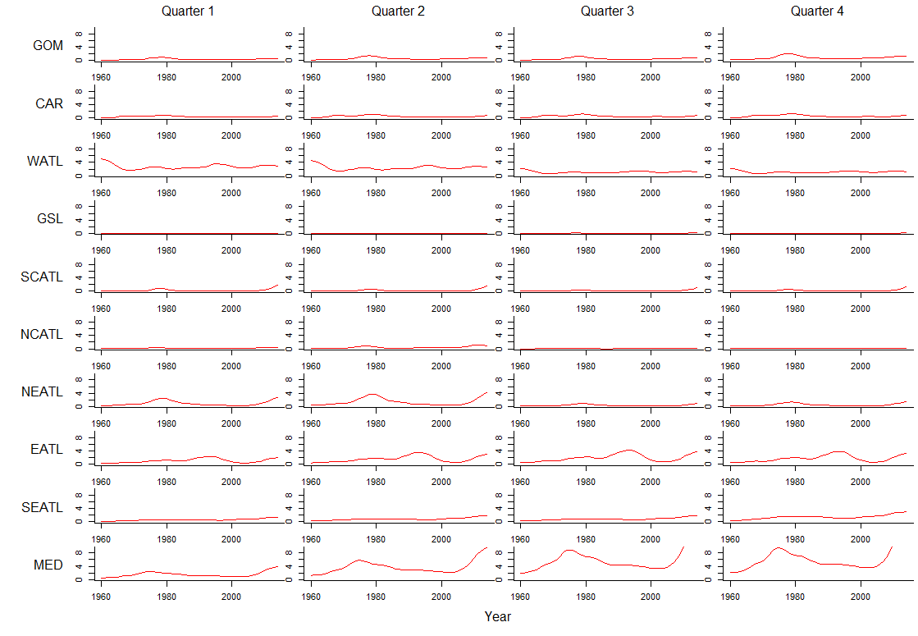
Figure 2.1. The preliminary master index. Areas correspond to those of Figure 1.1.

Table 2.2. The recorded quarterly transitions for electronic tags of NOAA, DFO, WWF, AZTI, UNIMAR, IEO, UCA, FEDERCOOPESCA, COMBIOMA, GBYP of known stock of origin (i.e. those tags entering either the Gulf of Mexico or the Mediterranean). For example, there are 20 tags that at some point entered the Gulf of Mexico (Western fish) that exhibited a movement from the Gulf of St Laurence to the Western Atlantic.

Table 2.3. Distribution of fish that were sampled and assigned stock of origin across years, areas and quarters (N=3465).

BASIC DYNAMICS

Overview

The current operating model (‘M3’) is based on conventional age-structured accounting (e.g. Quinn and Deriso 1999, Chapter 8) which is common to stock assessment models such as Stock Synthesis 3 (Methot and Wetzel 2013), CASAL (Bull et al. 2012), Multifan-CL (Fournier et al. 1998) and iSCAM (Martell 2015).

The standard age-structured equations are complicated somewhat by the subyear temporal structure in which ageing and recruitment occur in a particular subyear. In this version of the model, spawning occurs for all stocks in a subyear ms, after subyear 1 (spawning in the Mediterranean and Gulf of Mexico is thought to occur after a period of movement early in the year).

Equations

Numbers of individuals N, for stock s, in a model year y, in the first subyear m=1, age class a, and area r are calculated from individuals that have moved $\vec{N}$, in the previous year, final subyear n_{m}, of the same age class subject to combined natural and fishing mortality rate Z:

$N_{s,y,m=1,a,r}={\vec{N}}_{s,y-1,n_{m},a,r}∙ e^{-Z_{s,y-1,n_{m},a,r}}$ (3.1)

where total mortality rate is calculated from annual natural mortality rate M, divided by the fraction of the year represented by the subyear t_{m}, and fishing mortality rate F, summed over all fleets f:

$Z_{s,y,m,a,r}={t_{m} M}_{s,a}\sum_{f}{F_{y, m,a,r,f}}$ (3.2)
Fishing mortality rate at age is derived from fishing mortality rate by length class FL and the conditional probability of fish being in length class l, given age a (an inverse age-length key, LAK).:

$F_{y,m,a,r,f}=\sum_{l}{{FL}_{y,m,l,r,f}}∙{LAK}_{s,a,l}$ (3.3)

The fishing mortality rate at length is calculated from an index of fishing mortality rate I, an estimated catchability coefficient q and a length selectivity ogive s, by fleet:

${FL}_{y,m,l,r,f}=q_{f}∙I_{y,f}∙s_{f,l}$ (3.4)

Selectivity is calculated by the Thompson (1994) ogive and an estimate of mean length L of an age class l:

$s_{f,l}=\frac{1}{1-s_{dome}}∙{\left(\frac{\left(1-s_{dome}\right)}{s_{dome}}\right)}^{s_{dome}}∙e^{s_{prec}∙s_{dome}∙\left(s_{mode}-L_{l}\right)}∙\frac{1}{1+e^{s_{prec}∙\left(s_{mode}-L_{l}\right)}}$ (3.5)

In the spawning subyear ms, ages advance by one and recruitment occurs. The model includes a plus group which is the final age class n_{a}:

$N_{s,y,ms,a,r}=\left\{\begin{aligned}{\vec{N}}_{s,y,ms-1,a-1,r}∙ e^{-Z_{s,y,ms-1,a-1,r}} \\ {\vec{N}}_{s,y,ms-1,a-1,r}∙ e^{-Z_{s,y,ms-1,a-1,r}}+{\vec{N}}_{s,y,ms,a,r}∙ e^{-Z_{s,y,ms,a,r}}\end{aligned} \begin{matrix}a<n_{a} \\ a=n_{a}\end{matrix}\right.$ (3.6)
Recruitment is derived from a mean recruitment estimate for each stock over the whole time period $\overline{R}$ which is assumed to occur in user-specified spawning areas rs.

$N_{s,y,ms,1,rs}={\overline{R}}_{s} exp⁡\left(ε_{R,y}^{}-σ_{R}^{2}/2\right)$ (3.7)

where ε_{R} is a random normal deviate with variance $σ_{R}^{2}$ and $σ_{R}^{2}$/2 is the bias correction to ensure that on average, recruitment deviations have a mean of 1.

Under projections the operating models use various approaches for modelling recruitment including Beverton-Holt and ‘hockey stick’ forms that predict recruitment from stock-wide spawning biomass. Spawning stock biomass is calculated from moved stock numbers in the previous year, and subyear prior to spawning subyear ms, weight of individuals at age w, and the fraction of individuals mature at age mat:

${SSB}_{s,y}=\sum_{a}{\sum_{rs}{{\vec{N}}_{s,y-1,ms-1,a,r}∙ e^{-Z_{s,y,ms-1,a,r}}}}∙w_{s,a}∙{mat}_{s,a}$ (3.8)

where weight is calculated from length at age l:

$w_{s,a}=α_{s}∙l_{s,a}^{β_{s}}$ (3.9)

and the fraction mature at age is assumed to be a logistic function of age with parameters for the age at 50% maturity γ, and slope ϑ:

${mat}_{s,a}=1/{\left(1+e^{{\left(γ_{s}-a\right)}/{ϑ_{s}}}\right)}$ (3.10)

Stock numbers for subyears that are not the first subyear of the year and are not the spawning subyear are calculated:

$N_{s,y,m,a,r}={\vec{N}}_{s,y,m-1,a,r}∙ e^{-Z_{s,y,m-1,a,r}}$ (3.11)

In each subyear, after mortality and recruitment, fish are moved according to an age-specific Markov transition matrix mov that represents the probability of a fish moving from area k to area r at the end of the subyear m:

${\vec{N}}_{s,y,m,a,r}=\sum_{k}{N_{s,y,m,a,k}∙{mov}_{s,m,a,k,r}}$ (3.12)

The movement matrix is calculated from a log-space matrix lnmov and a logit model to ensure each row (k) sums to 1:

${mov}_{s,m,a,k,r}={e^{{lnmov}_{s,m,a,k,r}}}/{\sum_{r}{e^{{lnmov}_{s,m,a,k,r}}}}$ (3.13)

Size/age stratification for movement models will initially be attempted for three age groups: 0-2, 3-8 and 9+ years (this will be kept the same for the Western Atlantic and the Eastern Atlantic/Mediterranean, but should be re-evaluated for the East as future data become available).

Movements from an area k to an area r that are considered to be implausible (e.g. from the Eastern Mediterranean to the Gulf of Mexico) are assigned a large negative number (essentially zero movement) in corresponding cells in these movement matrices. For each area k, from which individuals can move, one value is assigned zero and all other possible movements are assigned an estimated parameter ψ (since rows must sum to 1, there is one less degree of freedom):

${lnmov}_{s,m,a,k,r}=\left\{\begin{matrix}-1E10 \\ 0 \\ Ψ_{s,m,k,r}\end{matrix} \begin{matrix}no movement from k to r \\ first assigned possible movement from k to r \\ other possible movements from k to r\end{matrix}\right.$ (3.14)

This movement model can be simplified to estimate only those movements for which data have been observed (e.g.at least one tag track or conventional tagging observation).

Compared with spatially aggregated models, initialization is more complex for spatial models, particularly those that need to accommodate seasonal movement by age and may include regional spawning and recruitment. The equilibrium unfished age structure / spatial distribution cannot be calculated analytically. For any set of model parameters it is necessary to determine these numerically by iteratively multiplying an initial guess of age structure and spatial distribution by the movement matrix. The solution used here is to iterate the transition equations above (Equations 3.1, 3.6, 3.7, 3.11, 3.12) given a fishing mortality rate averaged over the first five years of model predictions until the spatial distribution of stock numbers converges for each of the subyears.

Prior to this iterative process an initial guess at the spatial and age structure of stock numbers $\hat{N}$ is made based on the movement matrix and natural mortality rate at age M:

${\hat{N}}_{s,m,a,r}={\overline{R}}_{s}∙e^{-\sum_{1}^{a}{M_{s,a}}}∙\sum_{k}{\frac{1}{n_{r}}{∙mov}_{s,m,a,k,r}}$ (3.15)

In years prior to the initial model year (e.g. before 1961), historical catches $\overline{C}$ for eastern and western areas (east/west of 45 degrees longitude) are used to initialize the model using stock reduction analysis (i.e. catches are removed without error from the asymptotic estimates of unfished numbers $\hat{N}$). Mean historical annual catches were divided up among areas and seasons assuming the same seasonal and spatial pattern of catches as the initial years of the modelled time series (e.g. 1961-1965).

Stock numbers for initialization years (e.g. 1901-1960) are calculated using the same equations (i.e. Eqn 3.11 and 3.12) as model years (e.g. 1961 – 2015). The exception is that rather than using effort data, selectivities and an inverse age-length key (Eqns 3.3 and 3.4), fishing mortality rate at age is derived from mean historical catches and the assumption is made that these are taken without error in the middle of the time step with natural mortality rate occurring both before and after fishing:

$F_{i=1,m,a,r,f}=\left\{\begin{matrix}-log\left(1-\frac{{\overline{C}}_{m,a,r}}{{\hat{N}}_{s,m,a,r}e^{-\left({t_{m} M}_{s,a}\right)/2}}\right) & i=1 \\ -log\left(1-\frac{{\overline{C}}_{m,a,r}}{{\vec{N}}_{s,y-1,n_{m},a,r }e^{-\left({t_{m} M}_{s,a}\right)/2}}\right) & i>1, m=1 \\ -log\left(1-\frac{{\overline{C}}_{m,a,r}}{{\vec{N}}_{s,y,m-1,a,r}e^{-\left({t_{m} M}_{s,a}\right)/2}}\right) & i>1, m>1\end{matrix}\right.$ (3.16)

where i=1 is the first year and calculates fishing mortality rates from asymptotic numbers $\hat{N}$ (Eqn. 3.15).

Baseline

Recruitment freely estimated (no stock-recruitment model assumed when fitting operating model to data)
Recruitment calculated from stock-wide SSB for projections only
Gravity movement model used to calculate Markov movement matrix by subyear and stock
Movement calculated only for those transitions recorded by tagging

Alternative options

Hockey stick SR relationship (West)
Recruitment calculated from spawning area SSB
Markov movement matrix by subyear and stock (following model updates the gravity model – a specific case of the more general Markov model – seemed an appropriate choice for the Baseline).
Movement calculated for all transitions except stock exclusive spawning areas

Fleet structure and exploitation history

Table 3.1. Fleet definitions. Note that some fleets may be partitioned.

Baseline

A 14 fleet model based on the definitions of Table 3.1.

Alternative options

A proposal for alternatives may need to be developed and reviewed in the future.

MANAGEMENT OPTIONS

Notes:
- The following section is included to provide some suggestions on possible structures to MP developers of management options to be included in the MPs. The suggestions offered are illustrative – clearly they will need to be discussed with stakeholders as the process develops.
- As above, for convenience they have been set out in baseline and alternative option form. It is recommended that many of the choices for the final MP options be made later in the process, so that they can be informed by results from trials which show the pro/con trade-offs amongst such options.
- The specifics of future candidate MPs will be left to their developers to determine based on the results of their application to the finalised trials. However those candidates need to take account of the broad desired characteristics/limitations set out below.
- HCRs need not to explicitly include reference points

Spatial strata for which TACs are set

Baseline

Conventional West and East/Mediterranean regions (Figure 1.1):

West: areas 1-4 (GOM, CAR, WATL, GSL).
East+Med: areas 5-10 (SCATL, NCATL, NEATL, EATL, SEATL, MED).

Alternative options

Various possibilities exist, based on alternative combinations of the spatial strata defined in Item 1. For example, separating out the central Atlantic (Figure 1.1A).

West: areas 1-4 (GOM, CAR, WATL, GSL).
Central: areas 5-6 (SCATL, NCATL).
East+Med: areas 7-10 (NEATL, EATL, SEATL, MED).

However it is suggested that consideration of such more complex options be postponed to a “second round”.

Options for the frequency of setting TACs

Baseline

Every two years, for both West and East+Med (or alternative spatial strata) together

Alternative options

- Every three years
- Every four years

Upper limits on TACs

[Note that this option has potential advantages for reducing risk and avoiding over-capitalisation.]

Baseline

No upper limit

Alternative options

West e.g. 5 000, 6 000 mt
East +Med e.g. 30 000, 40 000 mt

Minimum extent of TAC change

Baseline

No minimum.

Alternative options

West e.g. 200, 300 mt
East +Med e.g. 1 000, 2 000 mt

Maximum extent of TAC change

[Note the underlying rationale is to promote industrial stability.]

Baseline

West 20%
East +Med 20%

Alternative options

West 15%
East +Med 15%

Note that developers of candidate MPs should consider including options which:
- Override such restrictions on the maximum extent of reduction if abundance indices drop below specified thresholds.
- Allow for greater increases (in terms of tonnage) if a TAC has had to be reduced to a low level and indices confirm subsequent recovery.

Technical measures

Size restrictions might be considered on a fleet and/or spatial stratum basis. However, for a “first round” it is suggested that these not be included explicitly, but instead be considered to be effected implicitly through the selectivity prescriptions for future catches by the various fleets which are set out under item 6 below.

FUTURE RECRUITMENT AND DISTRIBUTION SCENARIOS

See also section 9 of this document.

West

Functional forms fitted to assessment outputs for the years 1970+
- Hockey stick
- Beverton Holt with steepness h estimated

East + Mediterranean

Functional forms fitted to years 1950+
- Beverton Holt with h = 0.98 for 1950-1982, 1983+ and 1950+
- Beverton Holt with h = 0.70 for 1950-1982, 1983+ and 1950+

Note that 1950-1982 is “low” recruitment, and 1983+ is “high” recruitment.

Future regime shifts

West
- None
- After 10 years of projection, switch to other regime
- Probability of 0.05 every projection year of switch to other regime

East+Med
- 1983+ relationship continues unchanged
- 1983+ relationship changes to 1950-1982 relationship after 10 years
- Probability of 0.05 every projection year of a swop between 1983+ and 1950-1982 relationships

Note that for option c), it might be better to preclude changes over, say, the last 10 years of a 30-year projection period to ease interpretation of results through the reduction of transient effects.

Statistical properties

Residuals are taken to be lognormally distributed about the relationship assumed with the standard deviation of the log recruitments (σ_{R}) invariant over time.

Baseline

Uncorrelated residuals with σ_{R} = 0.5. (a common value obtained from the RAM legacy database).

Alternative options

σ_{R} and autocorrelation as estimated from the residuals for the conditioning concerned (post model fit, not within model fit, for greater statistical stability). For East+Med this will refer to the 1950+ fits.

Possible future distributional changes

Plausible options for future distributional changes (in relative terms) in response to changes in abundance and to possible environmental changes will be considered in a “second round”.

FUTURE CATCHES

Baseline

- Future catches will be taken to equal future TACs (up to a maximum harvest rate of 95%).
- The allocation of these future catches amongst fleets will be set equal to the average over 2012-2014
- The spatial distribution per stratum (see item 1 above) of these future catches will be set equal to the average over 2012-2014
- The selectivity function for each fleet for the most recent period for which this is estimated in the conditioning of the trial concerned will be taken to apply for all future years
- If the TAC is changed, the proportional allocation by fleet will remain unchanged, as will the proportional distribution by spatial stratum.

Alternative options

Clearly many are possible, but are probably best delayed until a “second round”. Were substantial changes to eventuate during a period when an MP was in operation, this would in any case likely necessitate re-tuning and re-testing or a modified MP.

The impacts of possible IUU catches should perhaps be considered under robustness trials (see item 9 below).

GENERATION OF FUTURE DATA

Note that these are for use as input to MPs, so need to be chosen carefully from a set of those highly likely to be regularly (i.e. annually) available. This is because application of the MP relies on these data being available in this way, so difficulties can (and have in other cases) obviously arise should they fail to do so. Though any candidate MP proposed should include a rule to deal with the absence of just one future value from an input series, any more than that would require re-tuning and re-testing of a modified MP, which is preferably planned to be avoided given the associated extra costs.

Consideration is also needed of the “delays” associated in such data becoming available for input to an MP. The customary default is that for computation of the TAC for year y, the most recent data finalised and available will be for year y-2. Any changes to that will require motivation and specification.

Baseline suggestions

West
- Gulf of Mexico larval index of spawning stock abundance
- Combined USA/Canada CPUE index currently under development
c) JLL_W CPUE index of exploitable abundance

East+Med
- JLL_NEA CPUE index of exploitable abundance
- Western Mediterranean larval index of spawning stock abundance
- GBYP aerial survey of adults
- Juvenile aerial survey Gulf of Lyon

Alternative options

Obviously many additions or alternatives to the suggestions made are possible. The reasons behind the initial suggestions above are respectively lengthy continuity (though admitting a concern about the decrease in spatial coverage of the JLL_NEA index over time) and fishery-independence. Accordingly the East + Med might be extended to include trap or baitboat indices.

Including additional indices of abundance will increase the workload (see below), so might be better postponed to a “second round”.

Catch-at-length series could also be considered for inclusion, but raise further technical complications regarding the specification of how they are generated, so are likely best deferred from consideration until a “second round”.

Relationships with abundance

For baseline trials, abundance indices will be taken to be linearly proportional to the appropriate component of the underlying model biomass in the stratum/strata concerned.

Possible alternatives to this are considered under Robustness trials (see item 9 below).

Statistical properties

Baseline
- Residuals are taken to be lognormally distributed about the relationship assumed with the standard deviation of the log recruitments (σ) invariant over time.
- The values of σ will be taken to be as estimated in the conditioning for the trial concerned.
- Autocorrelation of residuals will be taken to be zero.
- The conditioning results will be inspected for any indication of model mis-specification regarding the fit to the series concerned; if so the bias identified will be modelled to continue into the future in a “plausible” way.

Alternative options
- Fix σ values for all trials based on a central trial from the Reference set (see item 9 below).
- If additional CPUE indices to the single one initially suggested are included, residuals need to be examined for correlation, with this being taken into account in generating future values.

Other aspects

Currently a ‘master’ relative abundance index is used for the Mixed stock model which provides an estimate of relative abundance across all time-area strata (e.g. by year, quarter and area). The approach taken here is to include multiple fleets by dividing their catches by this ‘master’ index to provide an index of fishing mortality rate (a partial F) leaving only catchability by fleet to be estimated rather than several thousands of individual F parameters (by fleet, year, quarter and area). Simulation testing reveals that this approach provides unbiased estimates of central quantities such as abundance, stock depletion, mixing rate and selectivity. However the construction of the ‘master’ index is critical and this is an important axis of uncertainty for operating models.

MP input series (e.g. as suggested in section I, above) may however be specific fleet indices, rather than this master relative abundance index, and hence require generation into the future. This will be effected by including these series in the conditioning with comparisons to the resource components which they are assumed to reflect, but with a very low weight in the log-likelihood so as not to impact estimates of other parameters in the model fit. The estimates of the catchability coefficients, and statistical properties of the residuals of this fit will be used in generating values for this series forward in time.

Note that consideration should at some stage also be given to new data types that are only now becoming available (e.g. aerial surveys, genetic tagging). These will not at this stage have been collected over a sufficient length of time to be able to serve as MP inputs, but the overall testing process can be used to provide insight into their potential future utility.

PARAMETERS AND CONDITIONING

For the Baseline model, spawning is assumed to occur in areas ‘GOM’ for the West stock and ‘W.Med’ + ‘E.Med’ for the East + Mediterranean stock (Figure 1.1A).

Fixed parameters

Table 8.1. The parameters that are fixed (user specified)
Parameter | Number of parameters | Symbol
Steepness | n_{s} | H
Maximum length | n_{s} | Linf
Growth rate | n_{s} | Κ
Age at length zero | n_{s} | t₀
Natural mortality rate at age | n_{a} ∙ n_{s} | M
Selectivity of at least one fleet | 2-3 | Θ
Maturity at age | n_{a} ∙ n_{s} | mat

Table 8.2. Parameter values of baseline and alternative options
Parameter | West |  | East
Steepness (Bev.-Holt) | N/A (hockey-stick)  Estimated |  | 0.98  0.7
L1 (cm) (Richards) | 33.0 |  | 33.0
L2 (cm) | 270.6 |  | 270.6
K | 0.22 |  | 0.22
p₀ | 0.97 | 0.97
Natural mortality rate at age
East + West | 1 2 3 4 5 6 7 8 9 10 11 12 13 14+  0.38 0.30 0.24 0.20 0.18 0.16 0.14 0.13 0.12 0.12 0.11 0.11 0.11 0.10
Selectivity of at least one fleet | - Japanese Longline fleet is asymptotic -
Spawning fraction
Age  Low (East + West)  High (East)  High (West) | 1 2 3 4 5 6 7 8 9 10 11 12 13+  0 0 0.25 0.5 1 1 1 1 1 1 1 1 1  0 0 0.15 0.3 0.45 0 .6 0 .75 0.9 1 1 1 1 1  0 0 0 0 0 0 0.01 0.04 0.19 0.56 0.88 0.98 1

Estimated parameters

The majority of parameters estimated by the model relate to movement probabilities and annual recruitment deviations (Table 8.3).

Table 8.3. The parameters estimated by the model. The example is for a possible bluefin tuna operating model of 10 areas, 4 subyears, 14 fleets, 55 years and 26 age classes.
Parameter | Number of parameters | Example | Symbol
Mean recruitment | n_{s} | 2 | $$\overline{R}$$
Length a modal selectivity | n_{f} | 14 | s_{mode}
Precision of selectivity | n_{f} | 14 | s_{prec}
Dome-shape of selectivity | n_{f} | 13 | s_{dome}
Recruitment deviations | (n_{y +} n_{a} – 1) ∙ n_{s} | 160 | r
Fleet catchability | n_{f} | 14 | q
Movement (gravity model) | n_{r} ∙ n_{m}∙ n_{s} | 80 | ψ
Steepness (recruit. compensation) | n_{s} | 2 | h*
 | Total | 297
*Usually fixed rather than estimated.

Model predictions to compare with past data and likelihood functions

A summary of likelihood functions can be found in Table 8.4.

For each fleet f, total predicted catches in weight $\hat{C}$, are calculated from the Baranov equation:

${\hat{C}}_{y,m,r,f}=\sum_{s}{\sum_{a}{{w_{s,a}∙N}_{s,y,m,a,r}}∙\left(1-e^{-Z_{s,y,m,a,r}}\right)∙\left(\frac{F_{y,m,a,r,f}}{Z_{s,y,m,a,r}}\right)}$ (8.1)

Similarly predicted catches in numbers at age (CAA) are given by:

${\hat{CAA}}_{s,y,m,a,r,f}=N_{s,y,m,a,r}∙\left(1-e^{-Z_{s,y,m,a,r}}\right)∙\left(\frac{F_{y,m,a,r,f}}{Z_{s,y,m,a,r}}\right)$ (8.2)

This can be converted to a prediction of total catches in numbers by length class CAL using a stock specific inverse age-length key, LAK:

${\hat{CAL}}_{y,m,l,r,f}=\sum_{s}{\sum_{a}{{\hat{CAA}}_{s,y,m,a,r,f}∙{LAK}_{s,a,l}}}$ (8.3)

The model predicts spawning stock biomass indices $\hat{Issb}$, that are standardized to have a mean of 1 for each stock over the total number of years n_{y}:

${\hat{Issb}}_{s,y}=n_{y}∙{{SSB}_{s,y}}/{\sum_{y}{{SSB}_{s,y}}}$ (8.4)

The model predicts exploitable biomass indices $\hat{I}$, by fleet that are standardized to have a mean of 1 for each fleet:

${\hat{I}}_{y,m,r,f}=n_{y}∙n_{m}∙n_{r}{∙V_{y,m,r,f}}/{\sum_{y}{\sum_{m}{\sum_{r}{V_{y,m,r,f}}}}}$ (8.5)

where exploitable biomass V is calculated as:

$V_{y,m,r,f}=\sum_{l}{\left(s_{f,l}∙\sum_{s}{\sum_{a}{\left(N_{s,y,m,a,r,f}∙{LAK}_{s,a,l}∙w_{s,a}\right)}}\right)}$ (8.6)

The model predicts stock of origin composition of catches $\hat{SOO}$, from predicted catch numbers at age:

${\hat{SOO}}_{s,y,m,r,f}={\sum_{a}{{\hat{CAA}}_{s,y,m,a,r,f}}}/{\sum_{s}{\sum_{a}{{\hat{CAA}}_{s,y,m,a,r,f}}}}$ (8.7)

A log-normal likelihood function is assumed for total catches by fleet. The negative log-likelihood is calculated as:

${-lnL}_{c}=\sum_{y}{\sum_{m}{\sum_{r}{\sum_{f}{ln\left(σ_{catch}\right)+\frac{{\left(ln\left({\hat{C}}_{y,m,r,f}\right)-ln\left(C_{y,m,r,f}\right)\right)}^{2}}{2∙σ_{catch}^{2}}}}}}$ (8.8)

Similarly the negative log-likelihood components for indices of exploitable biomass and spawning stock biomass are calculated as:

${-lnL}_{i}=\sum_{y}{\sum_{m}{\sum_{r}{\sum_{f}{ln\left(σ_{index}\right)+\frac{{\left(ln\left({\hat{I}}_{y,m,r,f}\right)-ln\left(I_{y,m,r,f}\right)\right)}^{2}}{2∙σ_{index}^{2}}}}}}$ (8.9)

${-lnL}_{SSB}=\sum_{s}{\sum_{y}{ln\left(σ_{SSB}\right)+\frac{{\left(ln\left({\hat{Issb}}_{s,y}\right)-ln\left({Issb}_{s,y}\right)\right)}^{2}}{2∙σ_{SSB}^{2}}}}$ (8.10)

The length composition data are assumed to be distributed multinomially. In traditional stock assessment settings catch composition data may often dominate the likelihood function due to the large number of observations. This is exacerbated by a failure to account for non-independence in size composition samples. There are two possible solutions: (1) manually specify the effective sample size (ESS) of length-composition samples or (2) use a multinomial likelihood function that includes the conditional maximum likelihood estimate of the ESS (perhaps even a freely estimated ESS, S. Martell personal communication). In this version of the code, ESS is user-specified.

The negative log-likelihood component for length composition data is calculated as:

${-lnL}_{CAL}= -\sum_{y}{\sum_{m}{\sum_{l}{\sum_{r}{\sum_{f}{{CAL}_{y,m,l,r,f}∙ln\left({\hat{p}}_{y,m,l,r,f}\right)/{ESS}_{f}}}}}}$ (8.11)

where the model predicted fraction of catch numbers in each length class p, is calculated as:

${\hat{p}}_{y,m,l,r,f}={{\hat{CAL}}_{y,m,l,r,f}}/{\sum_{l}{{\hat{CAL}}_{y,m,l,r,f}}}$ (8.12)

Similarly the negative log-likelihood component for PSAT tagging data of known stock of origin (SOO), released in year y, subyear m, area r and recaptured in year y2, subyear m2, and area k is calculated as:

$-{lnL}_{PSAT}= -\sum_{s}{\sum_{y}{\sum_{m}{\sum_{y2}{\sum_{m2}{\sum_{r}{\sum_{k}{{PSAT}_{s,y,m,y2,m2,k}∙ln\left({\hat{θ}}_{s,y,m,y2,m2,r,k}\right)}}}}}}}$ (8.13)

where recapture probabilities θ, are calculated by repeatedly multiplying a distribution vector d, by the movement probability matrix mov. For example for a tag released on a fish of stock 1 in year 2, subyear 3, and area 4, the probability of detecting the tag in year 3, subyear 2 for the various areas is calculated as:

${\hat{θ}}_{s=1,y=2,m=3,y2=3,m2=2,r=4,1:n_{r}}=\left(\left(d∙{mov}_{s,m=3}\right)∙{mov}_{s,m=4}\right){mov}_{s,m=1}$ (8.14)

where

$d_{k}=\left\{\begin{matrix}0 \\ 1\end{matrix} \begin{matrix}k≠r \\ k=r\end{matrix}\right.$ (8.15)

The negative log-likelihood component for PSAT tagging data of unknown stock of origin PSATu, is currently weighted according to the compound probability that a fish is of a particular stock given the track history for that tag. For example for a tag t, tracked in series of years y_{i}, subyears m_{i}, and regions r_{i}, the weight w, of that tag for a specific stock is calculated as:

$w_{t,s}=\frac{\prod_{i}{\left[{\left(\sum_{a}{N_{si,yi,mi,ai,ri}}\right)}/{\left(\sum_{s}{\sum_{a}{N_{si,yi,mi,ai,ri}}}\right)}\right]}}{\prod_{i}{\left[1-{\left(\sum_{a}{N_{si,yi,mi,ai,ri}}\right)}/{\left(\sum_{s}{\sum_{a}{N_{si,yi,mi,ai,ri}}}\right)}\right]}}$ (8.16)

This is simply the product of fractions of that stock in those time-area strata divided by the product of the fractions of other stocks in those time-area strata. An alternative approach would be to compare the relative probabilities of the observed movements among the stocks although it is unclear whether this circularity (PSAT data are a primary source of information regarding movement) could lead to estimation problems.

The weighted negative log-likelihood function is similar to that of the stocks of known origin but includes the appropriate weighting term for each tag:

$${-lnL}_{PSAT}= -\sum_{t}{\sum_{s}{\sum_{y}{\sum_{m}{\sum_{y2}{\sum_{m2}{\sum_{r}{\sum_{k}{{PSATu}_{t, s,y,m,y2,m2,k}}}}}}}}}$$
$∙ln\left({\hat{θ}}_{s,y,m,y2,m2,r,k}\right)∙w_{t,s}$ (8.17)

The negative log-likelihood component for stock of origin data SOO is also calculated assuming a multinomial distribution:

${-lnL}_{SOO}= -\sum_{s}{\sum_{y}{\sum_{m}{\sum_{r}{\sum_{f}{{SOO}_{s,y,m,r,f}∙ln\left({\hat{SOO}}_{s,y,m,r,f}\right)}}}}}$ (8.18)

The global penalised negative log-likelihood -lnL_{T}, to be minimized is the summation of the weighted negative log-likelihood components:

$${-lnL}_{T}=-[ω_{c}∙{lnL}_{c}+ω_{i}∙{lnL}_{i}+ω_{SSB}∙{lnL}_{SSB}+ω_{CAL}∙{lnL}_{CAL}+$$
$ω_{PSAT}∙{lnL}_{PSAT}+ω_{PSATu}∙{lnL}_{PSATu}$] (8.19)

Table 8.4. Summary of the negative log-likelihood function contributions from various data
Type of data | Disaggregation | Likelihood function
Total catches (weight) | year, subyear, area, fleet | Log-normal
Index of exploitable biomass (e.g. a CPUE index used in the assessment) | year, subyear, area, fleet | Log-normal
Index of spawning stock biomass (e.g. a larval survey) | year, stock | Log-normal
Length composition | year, subyear, area | Multinomial
PSAT tag (known stock of origin) | stock, year, subyear, area, age class | Multinomial
PSAT tag (unknown stock of origin) | year, subyear, area, age class | Multinomial
Stock of origin | Year, subyear, area, age class | Multinomial

Characterising uncertainty

Baseline

Concentrate on among-model uncertainty using the maximum posterior density estimates of model parameters and a prior model weight based on expert judgement. Uniform weights will be used to start, possibly updated later using a Delphi-type approach.

Alternative options

Include within-model uncertainty (parameter uncertainty) via Monte Carlo sampling from the inverse Hessian matrix of model parameters.

Include within-model uncertainty via MCMC sampling of posteriors for model parameters.

TRIAL SPECIFICATIONS

Reference set

Three major uncertainty axes: future recruitment; current abundance; and natural mortality/maturity (in combination) for conditioning and projections. These axes assume that the options of East and West are linked across rows of the table below. This is done with the intention of capturing extremes.

 | West | East
Future recruitment
1 | Hockey-stick | 83+ B-H with h=0.98
2 | B-H with h estimated | 83+ B-H with h=0.70
3 | Hockey-stick changes to  B-H after 10 years | 83+ B-H with h=0.98 changes to 50-82 B-H with h=0.98 after 10 years
Current abundance
A | Best estimate | Best estimate
B | Three quarters best estimate | Half best estimate
Maturity
I | High age mat | Low age mat
II | High age mat | High age mat
III | Low age mat | Low age mat

Note that Option I reflects the current conventional assumptions for separate West and East+Med assessments. Further the current abundance estimates for Options A and B will be dependent on which of Options I, II or III applies for the scenario concerned. When modifying current abundance a highly informative prior will be placed on abundance that is a fraction (e.g. three quarters or half) of the best estimate.

Combinations for Reference Set

A full cross of (1, 2, 3) x (A, B) x (I, II, III), i.e. 18 scenarios in all.

Discussion will be required regarding whether, in addition to considering results for each of these scenarios individually, they should also be considered for all scenarios in combination, and if so how the scenarios should be weighted (if at all) in such a combination.

Robustness trials

Each of these is a single factor variant on each of two scenarios from the Reference Set: [1,A, I] and [2, A, I]

- Future recruitment change as in 3), but with prob of 0.05 for each of the first 20 years of projection
- Unrealised overcatches each year of [X] tons in the West and [Y] tons in the East+Med
- Use of alternative indices [to be specified] in the MP
- Alternative combinations of fleets in evaluating selectivities for the operating models
- An undetected increase in catchability for CPUE-based abundance indices of 1% per annum
- Alternative assignments to stock of origin of historical catches from the South Atlantic
- Alternative master index

“Second round” issues

The following aspects of uncertainty are suggested to be postponed at this time for consideration rather in a “second round”:

- More than two stocks
- More than two indices of abundance used as input to a MP
- Use of CAL data in an MP
- TACs allocated on a spatially more complex basis than the traditional west and East+Med
- Changes in technical measures affecting selectivity
- Changes in stock distributions in the future
- Future changes in proportional allocation of TACs amongst fleets

PERFORMANCE MEASURES/STATISTICS

Projections under candidates MPs will be for 100 years (unless this leads to computational difficulties) commencing in 2017. Prior to that, for projecting for years between the last year of the condition and 2017, the catches will be set equal to the TACs already set, with abundance index data (and any further monitoring data such as catch-at-length) not yet available for those years being generated as specified under item 7. Note that considering a period as lengthy as 100 years is not to imply high reliability for projections for such a long time, but to be able take account of transient effects that persist for some time for a long-lived species.

Summary measures/statistics

- Annual average catch for the first, second and third 10-year period of MP application.
- Spawning biomass depletion calculated relative to the deterministic equilibrium in the absence of catches for the recruitment function that applies after 10, 20 and 30 years of MP application.
- The lowest spawning biomass depletion over the 30 years for which the MP is applied calculated relative to the deterministic equilibrium in the absence of catches for the recruitment function that applies after 30 years.
- Spawning biomass depletion after 30 years, but calculated relative to the trajectory that would have occurred had no catches been taken over the full period for which MP application is being considered.
- The lowest spawning biomass depletion over the 30 years for which the MP is applied, but calculated relative to the zero catch trajectory specified in d).
- Kobe or alternative Kobe indicators (catch/biomass instead of Fmsy and biomass/biomass at a theoretical maximum MSY)
- Average annual variation defined by:

(13.1)

For each of these distributions, 5%-, 50%- and 95%iles are to be reported from 200 replicates. Note the reason for measures/statistics c) and e) is to compensate for regime changes. The choice of these percentiles may need further exploration with stakeholders.
Further stakeholder orientated measures may need to be included. These must be scientifically based, easily understood by stakeholders and such that managers may readily request the evaluation of any changes in options.

Summary plots
Catch and spawning biomass trajectories plotted as:

- Annual medians with 5%- and 95%-ile envelopes
- 10 worm plots of individual realisations

Note that repetitions for different options for selectivity may be needed.

Level of reporting

Baseline

- Catch-related measures/statistics by traditional West and East+Med regions.
- Spawning biomass depletions measures/statistics by separate stocks

Alternative options

Many can be conceived, likely related primarily to catch and depletion by some combination of stock and/or spatial stratum. However these might be left for a “second round”, as they would become more pertinent in the face of greater model complexities possibly introduced at that time, such as changing spatial distributions of stocks and/or catches (resulting from changed proportional allocations to different fleets).

